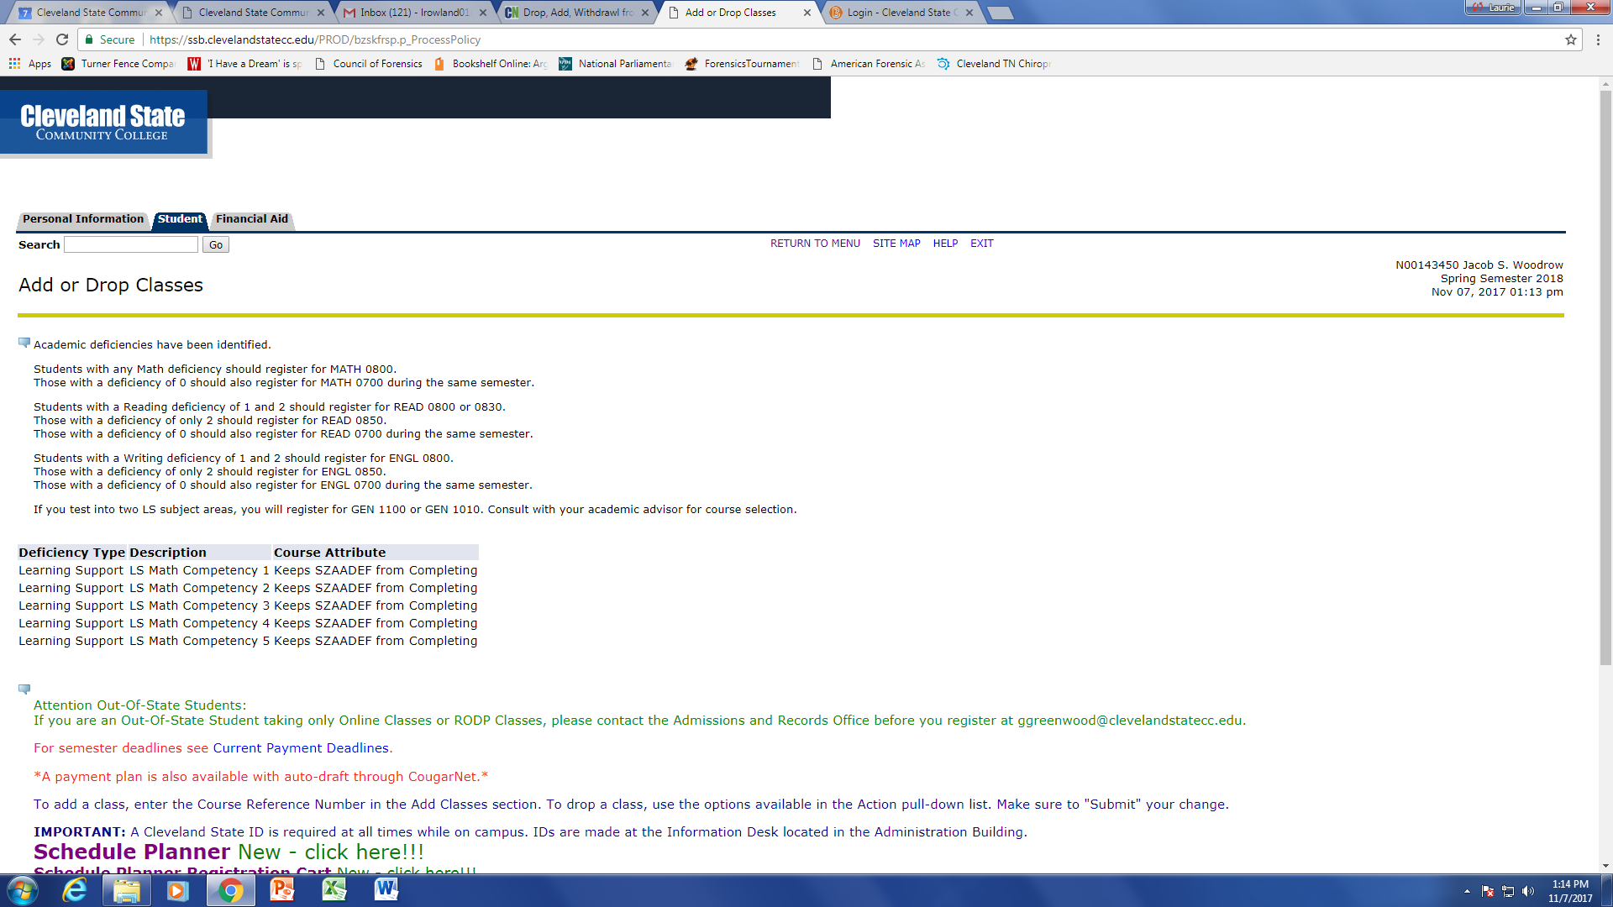


CSCC Forensics Classic
Speech & Debate Tournament

October 20 & 21, 2018

Dear Colleagues:

Cleveland State Community College proudly invites you to attend the inaugural CSCC Forensics Classic Speech and Debate Tournament on October 20th & 21st, 2018. The tournament will feature competition in all eleven AFA individual events plus radio broadcasting and NPDA. The debate will offer novice and open divisions with four preliminary rounds and an appropriate number of elimination rounds.

The entry deadline is Monday, October 8th, 2018 by 5:00 p.m. Email is preferable (see attached entry form) at lrowland01@clevelandstatecc.edu Fees may be paid upon arrival at the registration table, via cash or check (payable to CSCC/CSCC Debate Team). Awards will include:

Sweeps Awards:
- Awards for the top three large and small four-year schools in I.E.
- Awards for the top three large and small four-year schools in NPDA debate
- Awards for the top community college in NPDA debate and I.E.
- Grand Champion sweepstakes award

Individual I.E. Awards
- Pentathlon awards for the top six competitors entered in at least five I.E. events
- Awards for the top six competitors in I.E. events
- Awards for the top novice in each I.E. event

NDPA Debate Awards:
- Awards for the top six speakers in open and novice
- Awards for debate elims through semis

I have included directions to our campus, a campus map, a schedule of events, event information and rules, lodging suggestions, and entry fee information and registration materials. Please contact me if you have any questions or concerns.

Cordially,

Ms. Laurie Rowland
Assistant Professor of Communication, Humanities Department
Cleveland State Community College
3535 Adkisson Drive | Cleveland, TN 37320
Cleveland campus Office 423-473-2333 | Athens site office 423-473-2459| http://www.clevelandstatecc.edu

Directions to Cleveland State Community College

From 75 South:
Take Paul Huff Parkway/Cleveland Exit 27, take a right at the end of the exit onto Paul Huff Parkway. At first red light, turn left onto Adkisson Dr. Continue 1 mile and Cleveland State Community College will be on the right. Please park in the lot on left.

From 75 North:
Take Paul Huff Parkway/Cleveland Exit 27, take a left at the end of the exit onto Paul Huff Parkway. At first red light, turn left onto Adkisson Dr. Continue 1 mile and Cleveland State Community College will be on the right. Please park in the lot on left (circled in yellow)
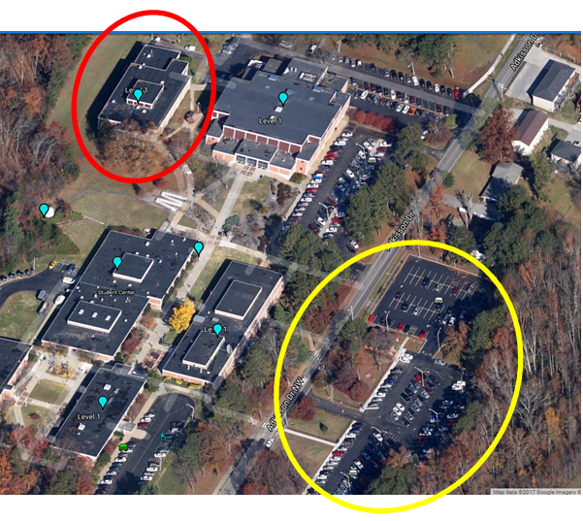

We will be meeting in the Humanities building (circled in red).

Lodging

Fairfield Inn & Suites by Marriott: 2815 Westside Dr NW, Cleveland, TN 37312 (423) 664-2501
La Quinta Inn & Suites: 130 Interstate Dr NW, Cleveland, TN 37312 (423) 813-7300
Wingate by Wyndham: 110 Interstate Dr NW, Cleveland, TN 37312 (423) 478-1212
Comfort Inn & Suites: 107 Interstate Dr NW, Cleveland, TN 37312 (423) 339-1000
Holiday Inn Express & Suites: 4355 Holiday Inn Express Way Northwest, Cleveland, TN 37312 (423) 790-1199
Hampton Inn: 4355 Frontage Rd NW, Cleveland, TN 37312 (423) 458-1222
TownePlace Suites by Marriott: 160 Bernham Dr NW, Cleveland, TN 37312 (423) 716-6737

Food During the Tournament

For Friday, we will have access to the campus café with a variety of foods. I will send a menu with your reservation to preorder lunch. Please note the cost on the menu for each meal.
We plan to offer breakfast and lunch on Saturday in addition to an assortment of snacks throughout both days. Saturday’s meals are included in an $8 per person fee. As the schedule is tight, please consider staying on-campus to avoid the hassle of waiting for teams to return. Please note the number of vegetarians on the entry form so that we can provide enough options for all.

Campus Map

An interactive campus map can be found at https://pointsmap.com/cscc/ .

Individual Event Patterns

Flight A Flight B

ADS DI
DUO EXT
IMP PER
INF POI
POE PRO
RADIO BROADCASTING CA

Entry Limitations for NPDA Debate and IEs

- NPDA debaters may enter any IE events, including prep events (Radio and Extemp).

- All students must sign into rounds before competing to ensure being adjudicated.

Special Notes

Internet Access

Competitors will be allowed to use the Internet during their preparation time. CSCC has guest Wi-Fi access available in most areas. However, a perfect Wi-Fi connection is not guaranteed. Access to electrical outlets will be limited in the preparation room.

Radio Broadcasting

Contestants will be given a packet of source materials and will have 30 minutes to select, organize, and present a simulated radio broadcast. The source material packets will include international, national, state, and local news. All material used in the broadcast must be provided by the tournament with the exception of any hypothetical station call letters, time, and current weather conditions or forecast. Students will present their broadcasts seated at a table with the judge facing away from the contestants during the speech. Students may time themselves as no time signals will be given by the judge. Maximum time limit for the speech is 5 minutes.

Tournament Observers

Some CSCC instructors may encourage their students to observe rounds. The faculty has been informed that they should discuss proper audience etiquette with their students prior to attending the event.

Entry Fees for the CSCC Forensics Classic Tournament

Individual Event Entries $8.00 (per entry)
NPDA Debate Entries $60.00 (per team)

Uncovered Individual Event Entries $12.00 (plus entry)
Uncovered NPDA Debate Entries $60.00 (plus entry)

IE Drops on Wednesday October 17th $12.00 (per entry)
IE Drops at Registration $20.00 (per entry)
Dropped Judges $60.00 (per judge)
NDPA Debate Team Drops at Registration $80.00 (per team)

Meal Fee $8.00 per competitor added to school total

Judge Options:

One judge will cover six individual event entries and/or two parliamentary debate entries.

CSCC Forensics Classic Flights and Event Rules

Flight A Flight B

Radio Broadcasting EXT
ADS DUO
DI POE
PRO INF
PER POI
IMP

PATTERN A EVENT RULES

Radio Broadcasting:
In this event, each student will receive a packet of news-copy or a newspaper. The student will report to a preparation room where s/he will have 30 minutes to select and organize the material into a 5 minute radio news broadcast. Judges will listen to (not watch) the presentation. Throughout the broadcast, the timekeeper or judge will keep the student informed of time. Students may use their own introductory remarks and transitional material, but they may not introduce advertisements, fillers or any other material that is not present in the copy provided by the tournament staff.
Time: 5 minutes; 5 second grace over or under time.

After Dinner [ADS]:
A speech designed to entertain the audience. This should not be a series of jokes, but should emphasize wit and creativity while following a central theme. It may be done with/without notes.
Maximum time limit: 10 minutes

Dramatic Interpretation [DI]:
A cutting from a play or plays of literary merit that may be humorous or serious. This involves the portrayal of one or more characters presented by one individual. This is not an acting event -- no costumes, props, lighting, etc. are to be used. Presentation is from the manuscript and the focus should be off-stage.
Maximum time limit: 10 minutes. Time limit includes original introduction.

Prose [PRO]:
Program may consist of single or multiple selections around a central theme. Manuscripts are to be used. Introduction and transitions should be delivered extemporaneously. Plays are not permitted. Maximum time limit: 10 minutes.

Persuasion [PER]: The speech must be original and the product of the contestant’s own thinking. The speech must be persuasive in the broadest sense of the word. Notes may be used. Maximum time limit: 10 minutes.

Impromptu [IMP]:
For this event, each student will receive the same topic. 7 minutes is allocated for preparation and speaking time, of which at least three minutes must be devoted to speaking. All contestants in a section will address the same quotation.

PATTERN B EVENT RULES

Extemporaneous Speaking [EXT]:
Topics will be from current events (foreign/domestic) since September 1, 2016. Contestants will choose one topic. There will be a half-hour preparation time before each speaking round. Notes may be used.
Maximum time limit: 7 minutes.

Duo Interpretation [DUO]:
A cutting (scene) from a play (either humorous or dramatic in tone) which involves the portrayal of two or more characters presented by two individuals. This is not an acting event and no costumes, props, lighting, etc. are to be used. Presentation is from the manuscript and the focus should be off-stage and not to each other. A contestant may enter two duos with different partners. Duo only counts once for Pentad competition.
Maximum time limit: 10 minutes. Time limit includes original introduction.

Poetry [POE]:
Program may consist of single or multiple selections around a central theme. Introductions and transitions should be delivered extemporaneously. Manuscripts are to be used.
Maximum time limit: 10 minutes.

Informative [INF]:
An original, factual speech on a realistic subject to fulfill the general goal of informing the audience. Research should be involved -- should not be simply personal experience or the retelling of a movie plot, etc. Visuals are permitted. Notes may be used.
Maximum speaking time: 10 minutes.

Programmed Oral Interpretation [POI]:
A program of thematically linked selections of literary merit, chosen from two or more of the recognized genres of competitive interpretation (prose/poetry/drama).
Maximum time limit: 10 minutes. Total time includes original introductions and transitions.

CSCC Forensics Classic Speech & Debate Tournament Schedule

Friday Saturday

9:00 Registration (Humanities Building, in front of Rm H-127) 7:30 Breakfast (Humanities building 1st floor
hallway)
10:00 NPDA Topic Announcement (H-127) IE Registration (Humanities Building, in
front of Rm H-127)
10:15 NPDA Round 1
8:00 Radio Draw (H-125)
11:15 NDPA Topic Announcement (H-127) Round 1 - Flight A

11:30 NPDA Round 2 9:45 Extemp Draw
Round 1 – Flight B
12:30 Lunch (Humanities building 1st floor hallway)
11:00 Radio Draw (H-125)
1:30 NDPA Topic Announcement (H-127) Round 2 – Flight A

1:45 NPDA Round 3 12:30 Lunch (Humanities building 1st floor
hallway)
2:45 NDPA Topic Announcement (H-127)
1:30 Extemp Draw (H-125)
3:00 NPDA Round 4 Round 2 – Flight B

4:30 NDPA Topic Announcement Semifinals (H-127 3:00 Radio Draw Finals (H-125)
Finals – Flight A
4:45 NPDA Semifinals
4:30 Extemp Draw Finals (H-125)
5:45 NDPA Topic Announcement Finals (H-127) Finals – Flight B

6:00 NDPA Finals 6:30 Awards Ceremony (Johnson Center
auditorium)
7:30 Awards Ceremony (Johnson Center auditorium)

